Description of Software Components used to Implement the META II to DESYRE Tool Flow for Hybrid Simulation

Author: L. Mangeruca, A. Ferrari
Date: Friday, September 23, 2011

How to Contact ALES S.r.l.

Web: www.ales.eu.com

+39 06 93385986 (Phone)
+39 06 93380118 (Fax)

ALES S.r.l. - Advanced Laboratory on Embedded Systems S.r.l.
Via Barberini, 50
00187 Roma, Italy

Table of Contents
Table of Contents 3
Tool flow and main software components 4
META II internal model builder 5
META II validator 5
META II to DESYRE translator 5
Modelica importer 5

Tool flow and main software components
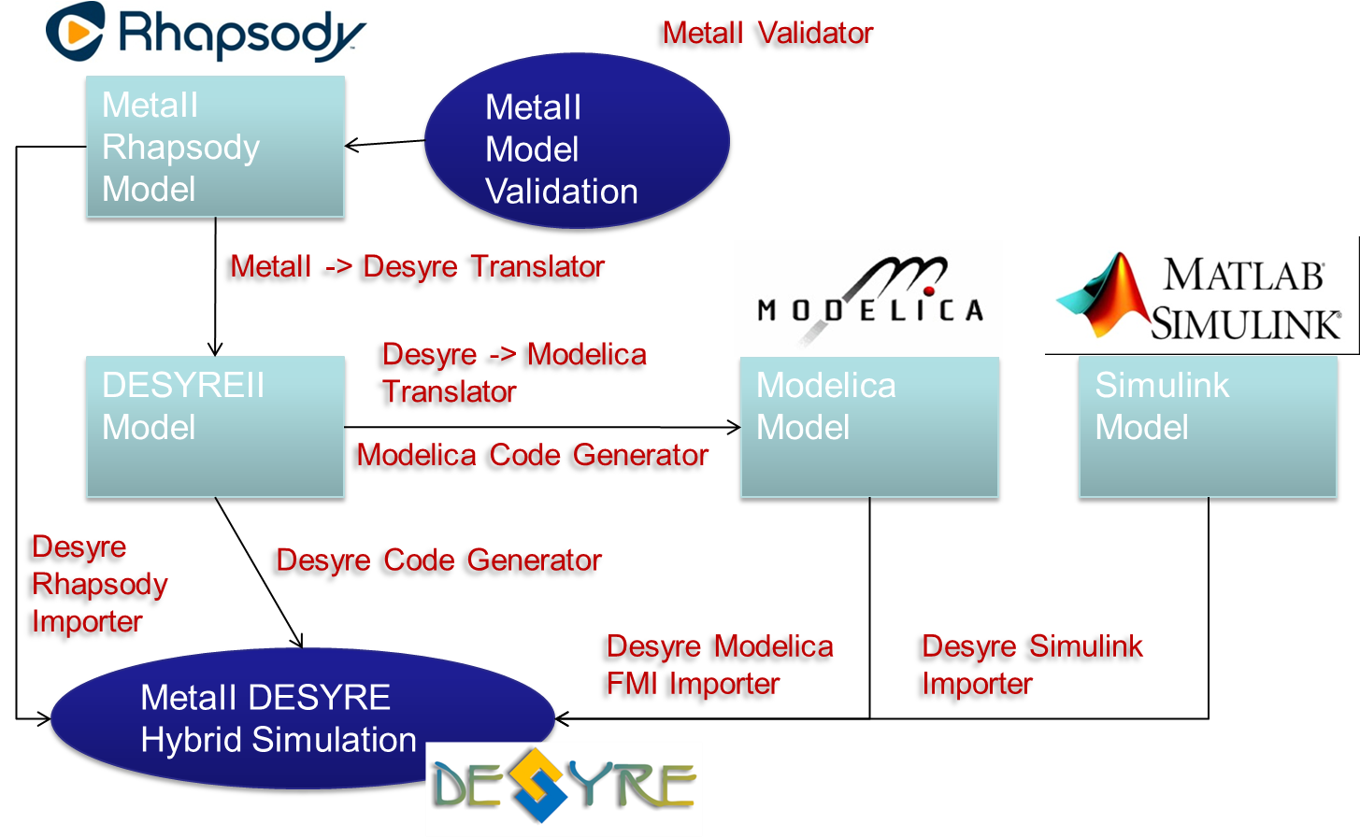
Figure 5: Automated tool flow for hybrid simulation
The integrated model is built in DESYRE for hybrid simulation purposes using an automated tool flow, shown in Figure 5. The automated tool flow consists of several tool components:
- META II internal model builder: reads the Rhapsody integrated model and builds an internal META II representation of it; this component has been developed in the scope of the META II project;
- META II validator: validates that all models of computation specified in the integration model be consistent, in particular, for each connector, it validates that the input end be associated with a model of computation that is equal or more general than the model of computation associated with the output end, so to ensure that no information is lost in the connector; the generalization relations between the models of computation are defined in the META II language profile; this component has been developed in the scope of the META II project;
- META II to DESYRE translator: translates the META II integrated model to a corresponding DESYRE internal representation for hybrid simulation; this representation also contains information of the tools from which models are to be imported; this component has been developed in the scope of the META II project;
- DESYRE to Modelica translator: the electrical network structure, specified in Rhapsody, is translated into an Modelica internal model; this component has not been developed in the scope of the META II project;
- Modelica code generator: Modelica code is generated out of the Modelica internal model; this component has not been developed in the scope of the META II project;
- DESYRE code generator: DESYRE code for simulation is generated out of the DESYRE internal representation of the integrated model; this is a pre-existing component;
- Modelica importer: a Modelica FMU corresponding to the electrical network is exported using a suitable modelica tool (e.g., jModelica) and imported as a DESYRE FMI blackbox; this component has been developed in the scope of the META II project;
- Simulink importer: a Simulink S-function corresponding to the thermal component is exported using RTW code generator and imported as a DESYRE S-funciton blackbox; this is a pre-existing component.
In the following sections we briefly describe the functionalities implemented in the software components developed in the scope of the META II project.

META II internal model builder
This component relies on:
- Rhapsody API: used to navigate the Rhapsody META II project through the Rhapsody application;
- The “com.eu.ales.rpyplugins.model” Java package and subpackages: defines the META II EMF metamodel;
- The “com.eu.ales.rpyplugins.utils” Java package and subpackages: provides utilities for building the META II EMF internal model;
- The “com.eu.ales.rpyplugins.rpyparser” Java package and subpackages: provides utilities to read the META II Rhapsody project into the META II EMF internal model.

META II validator
This component relies on:
- The “com.eu.ales.rpyplugins.model” Java package and subpackages: defines the META II EMF metamodel;
- The “com.eu.ales.rpyplugins.metaiivalidator” Java package and subpackages: provides utilities to validate the model based on validation rules that are defined as stereotypes in a dedicated Rhapsody profile.

META II to DESYRE translator
This component relies on:
- The “com.eu.ales.rpyplugins.model” Java package and subpackages: defines the META II EMF metamodel;
- The “com.eu.ales.desyre.model” Java package and subpackages: defines the DESYRE EMF metamodel (pre-existing);
- The “com.eu.ales.rpyplugins.metaii2desyre” Java package and subpackages: provides classes that define the mapping of META II EMF model elements to DESYRE EMF model elements. These classes extend classes of the ALES (pre-existing) JQVT implementation of the QVT standard language for model transformations.

Modelica importer
This component comprises DESYRE wrapping code for encapsulating the Modelica FMU exported executable and adapting it to the DESYRE simulation environment.

