Notebook Judging Tips Sheet

This document provides tips to consider while developing the team engineering notebook. An example outline can be found in the Music City BEST Team Handbook (under the General information on https://cps-vo.org/group/MCBEST/wiki). Be sure to look at the official Engineering Notebook Score Sheet (under Awards Score Sheets section) to understand how judges will be scoring the submissions.

IMPORTANT: All teams are required to submit an Engineering notebook.

Engineering Design Process 2
Engineering Notebook Contents 3
Notebook Development Team Organization 4
Notebook Editor Role 4
Notebook Secretary Role 4
Notebook Specification 5
Think About Your Page Layout 5
Try to Omit Needless Words 6
Writing Style 6
Don’t Forget Graphics! 7
Pro Tips to Maximize Your Notebook Score 7

Engineering Design Process

Below is the steps of the engineering design process:

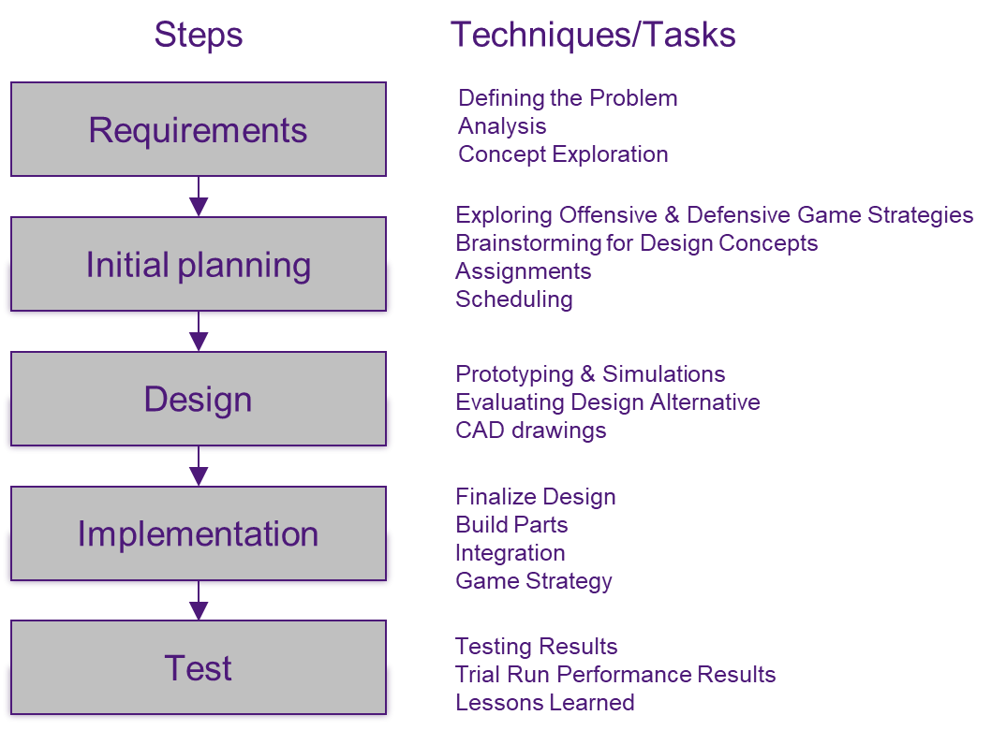

This process is really an iterative process. After the first design is determined, testing begins to verify the concepts will work as desired. If it does not work correctly, then determine another concept to try. Once the concept works, then building moves forward. As a section of the robot is complete, testing is done to make sure you built what you expected. Adjustments are made as needed. Once the robot is assembled and working, the robot is once again tested and the robot adjusted to pass the tests. All of these efforts are part of the engineering design process and should be reflected in the engineering notebook information.

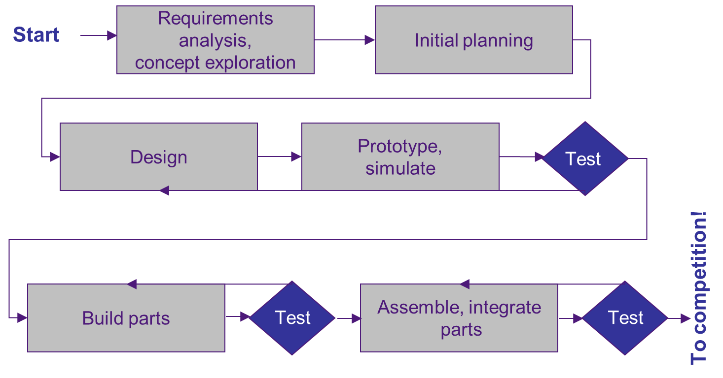

Engineering Notebook Contents

Here are some ideas of what could be created for the notebook:

- Requirements
  - Analysis of game strategies
  - Your team’s strategy and goals in the game
  - The robot requirements needed to meet your strategy and goals
- Initial Planning
  - Show brainstorming results
- Design
  - How the team determined the design
  - What alternate ideas were considered in the design process?
  - Were any solutions particularly creative
  - Impact of strategy decisions on the design
  - Mathematical and physics analysis, equations and formulas used
  - Explain software design
- Implementation
  - Describe how the team built the robot
  - Decisions that affected how the robot was built
  - How was software design verified?
- Test
  - How was testing performed?
  - How will you know when you have met your goals (testing results)
  - Test results of all robot design options
  - Analysis of both successes and failures
  - Changes made to robot resulting from tests
- Other
  - Provides evidence of how the Engineering Design Process was followed
  - Demonstrates that safe practices were followed
  - Team schedule and assignments
  - What your team learned that might help with future competitions
- Includes a Research Paper – 2 to 5 Pages

Notebook Development Team Organization

- Identify the notebook development team
  - This shouldn’t be a one person effort!
- Leaders
  - Notebook Editor – notebook planning, writer coordination, writing, editing, page design, assembly
  - Secretary – photos, scanning brainstorming sketches, activity logs (team activities, decisions, accomplishments), demographics
- All robotics team members should play some role
  - Not everyone will write the notebook, but everyone should contribute information

Be sure to plan ahead!!!!
- Have an initial plan and schedule
  - What is needed?
  - Who is going to do what, when?
  - What do you need to do it?
  - How are you going to do it?
  - How long will it take?
  - How will I know when I’m there?
- Think about the audience
- Create an outline
- Organize your information
- Decide what graphics you need for each section
- Finalize assignments and schedule

Notebook Editor Role

- Specify the word processing program to be used
- Establish a deadline for all submissions
- Determine the notebook style design
  - Writers should not be concerned about formats, spacing, margins, etc.
- It is easier for the Editor if each writer simply provides text
  - Editor can easily take care of the formats, spacing, margins, etc. after all the text is assembled into one file
- Make sure each student writing a section understands what is included and what should NOT be included

Notebook Secretary Role

- Pictures and sketches are a vital part
- Secretary responsibilities
  - Accumulating, sorting, and filing pictures
  - Scanning brainstorming sketches into electronic files
- Each writer should have access to them and can insert them into the document as needed
  - Otherwise, the Editor will have to edit submissions and choose appropriate pictures and sketches to insert

Notebook Specification

- Number of Pages: 35 pages or less
  - Note that the Title and Table of Contents pages will not be counted as part of the 35 pages
- Cover sheet or title page must identify the school, team name, teacher contact, and team number
- Page Format: Standard, 8 ½” x 11” paper, double-spaced, 1” margins
- Font: Times New Roman (preferred) or similar business-style font no smaller than 12 point
- Single-spacing is acceptable in tables and outlines
- Research Paper: include a description of how the current year’s game theme is related to current technological practices or scientific research
  - Minimum of 2 pages, maximum of 5 pages
  - Included in the 35 page count
- Teams may include a supplemental appendix of no more than 40 pages in length
  - May include support documentation such as drawings, photos, organization charts, minutes of team meetings, test results, etc.
  - This material should directly support the process described in the primary document and NOT reflect activities related to community or promotional efforts, spirit development, or team-building

Think About Your Page Layout

- Keep it simple!
- Don’t use too many fonts or colors!
  - Max 4 colors per page
  - Max 3 fonts – use bold and italic sparingly
- Don’t use quotes and underlining
- Use white space, avoid clutter
- BE CONSISTENT!
  - If multiple people are creating different sections, make sure they all come together as one single book
- Omit needless words
- Writing should be concise and clear
- Use a stylebook for grammar, punctuation, abbreviation, capitalization, etc.

Try to Omit Needless Words

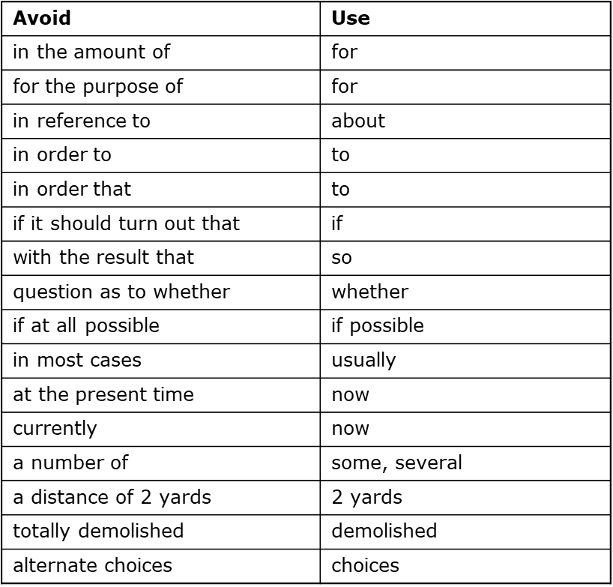

Writing Style

- Do not use “I” and “we,” always use third person such as:
  - The base design team developed …
  - The arm design team built a prototype of …
  - The BEST Robotics team decided to use a strategy of …
- Avoid passive voice
  - “The robot was built by the students.” (passive) vs “The students built the robot.” (active)
- Use a personal, conversational tone
  - Make sure it sounds natural when read aloud
  - Ask another person to read and provide inputs
- This is not a creative writing assignment
  - It must maintain a technical focus throughout by being well organized, unambiguous, and “to-the-point”
- Focus on what is important and put that first
- ALL content in the Project Notebook must support the design process, no extraneous material
    - Things like marketing, outreach, tee-shirt design, etc should not be included anywhere in the Notebook.
- Use lists, tables and figures effectively
- No brain dumps! Follow your outline
- Run spell checker, but also have someone proofread
  - Spell checkers don’t catch misspellings that are legitimate words
- Number your pages

Don’t Forget Graphics!

- Keep them clean and simple
  - Don’t use too many colors and heavy lines
  - Clean up hand drawn figures and hand written notes
- Focus on what is important
  - Get photos of team members using tools, brainstorming, CADs to support your design
  - If a photo/chart/etc. does not have a caption and it is not clear how it is used in the text, then it should not be there.
- Label every graphic and reference it somewhere in the text
- Check the spelling in your graphics

Pro Tips to Maximize Your Notebook Score

- Have at least one flow chart! This is a process notebook, so show your process
- Organize your notebook to follow your process
- Include references to supplemental material
- Make sure captions for figures and tables are clear
- Be sure your notebook explains:
- Your team’s strategy and goals in the game
- Brainstorming results
- The robot requirements needed to meet your strategy and goals
- Alternate ideas
- How you will know when you have met your goals?
- Team schedule and assignments
- Does the notebook describe:
- How the team determined the design?
- Decisions that affected how the robot was built?
- Mathematical and physics analysis, equations and formulas used?
- Analysis of game strategies?
- Impact of strategy decisions on the design?
- Were any solutions particularly creative?
- Does the notebook include:
- Test results of all robot design options?
- Analysis of both successes and failures?
- What your team learned that might help with future competitions?
- Does supplemental documentation:
- Directly support the notebook content (engineering process)?
- Have a cross-reference somewhere in the main body of the notebook?
- Meet the page-count limit?

